DECIMALS
Introduction to Decimals
Numbers with a point are decimal numbers. For e.g. weight, height and interest rate in the following examples.
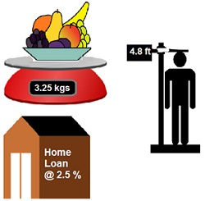
Decimals represent fractions. For e.g. In the following figure, One block divided into 10 equal parts. In fractional terms, each part is 1/10 (one-tenth) of a unit. It can be written as 0.1 in decimal notation.

Comparing Decimals
While comparing two decimal numbers, we consider the following rules:
We compare the place values of digits from left to the right.
Extra zeroes to the right of the last digit of a decimal value do not change the value of the number.
Extra zeroes between decimal point and a decimal digit do not change its value.
Question 1: Which is greater?
- 0.5 or 0.005
Answer: 0.5 > 0.005
- 0.7 or 0.5
Answer: 0.7 > 0.5
- 7 or 0.7
Answer: 7 > 0.7
- 1.37 or 1.49
Answer: 1.49 > 1.37
- 2.03 or 2.30
Answer: 2.30 > 2.03
- 0.8 or 0.88
Answer: 0.88 > 0.8
Question 2 Express as rupees using decimals: 7 paise
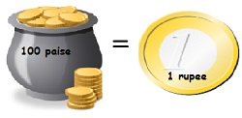

1 Rupee = 100 paise
100 paise = 1 Rupee
1 paise =1/100 Rupee
7 paise = 7/100 Rupee
7 paise = 0.07 Rupees
Thus, the answer is 0.07 rupees.

7 rupees 7 paise
1 Rupee = 100 paise
100 paise = 1 Rupee
1 paise =1/100 Rupee
7 paise = 7/100 Rupee
7 paise = 0.07 Rupees

Thus, the answer is 7 rupees + 7 paise = 7 rupees + 0.07 rupees = 7.07 rupees.
Question 3: Write the following decimal numbers in expanded form:
(a) 20.03
Answer:
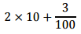
(b) 2.03
Answer:
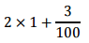
(c) 200.03
Answer:
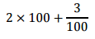
(d) 2.034
Answer:
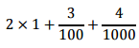

Question 4: Write the place value of 2 in the following decimal numbers:
- 2.56
Answer: One
- 21.37
Answer: Ten
- 10.25
Answer: One tenth
- 9.42
Answer: One hundredth
- 63.352
Answer: One thousandth

